Advanced Topics in Neuroscience HW5

Aliakbar Mahmoodzadeh 98106904

1. **RW rule, simulate, and plot the outcome of following paradigms:**

The Rescorla-Wagner rule:

𝑤(𝑖 + 1) = 𝑤(𝑖) + 𝜖 (𝑟(𝑖) − 𝑤(𝑖)𝑢(𝑖))

Stimulation:

1. Extinction: 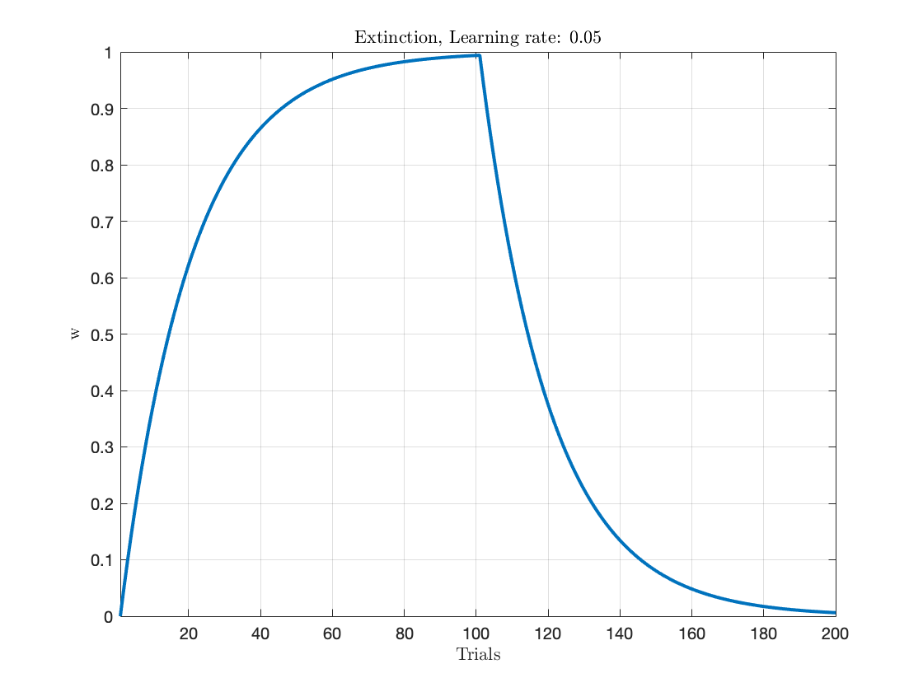
2. Partial: 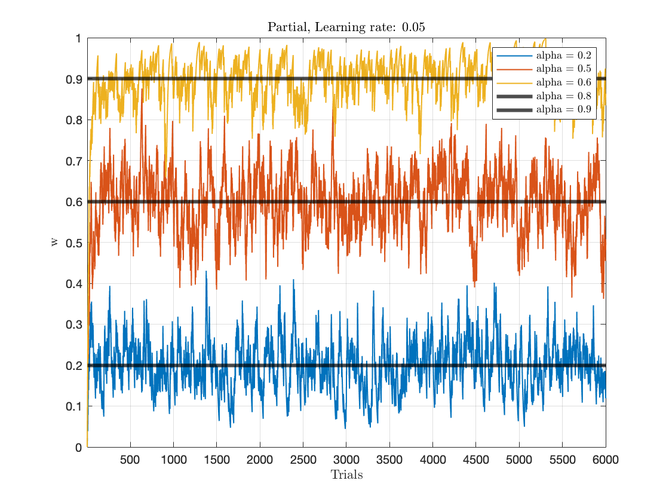

In the partial paradigm, the weight converges to the probability threshold

1. Blocking: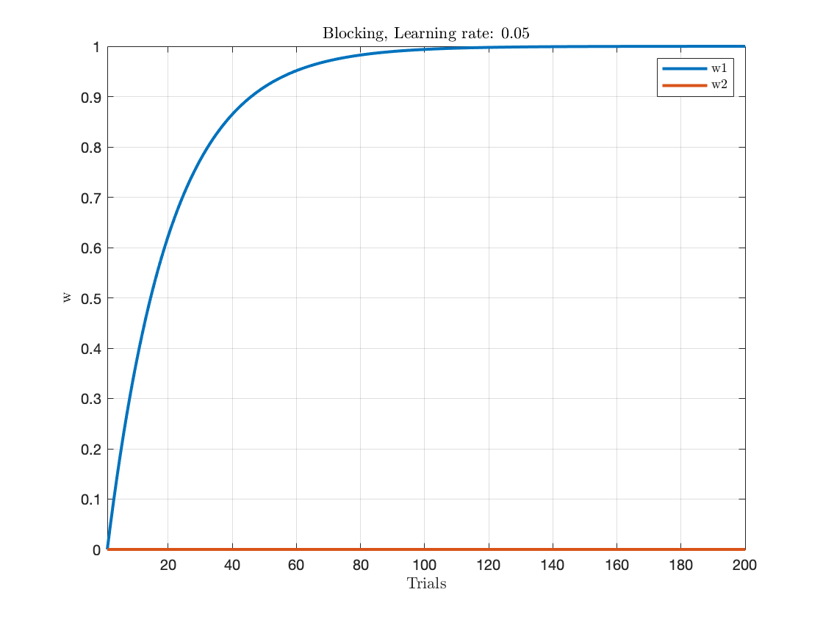
2. Inhibitory:

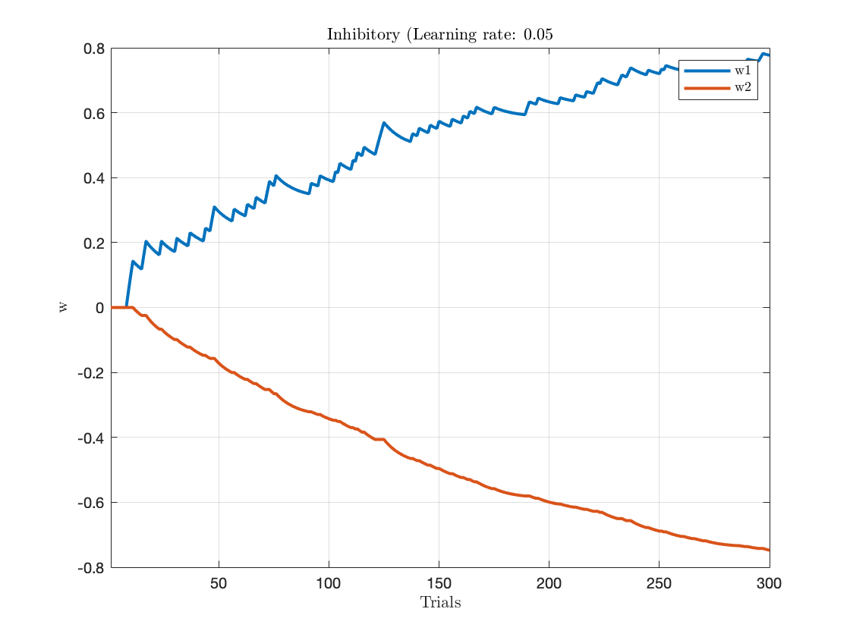

1. Over shallow

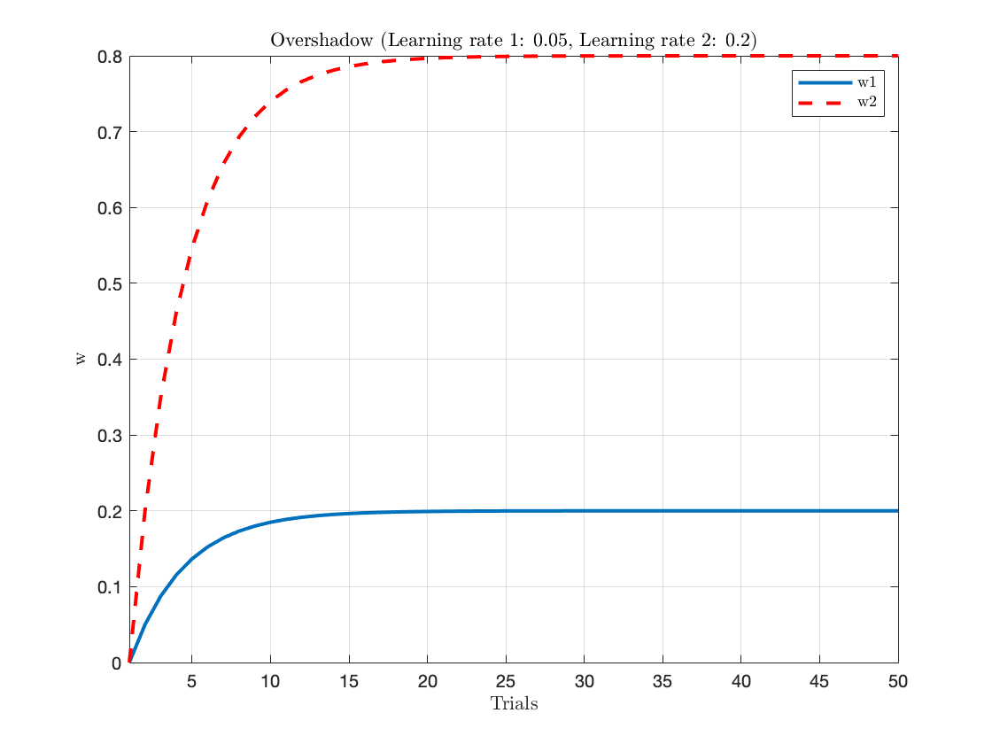

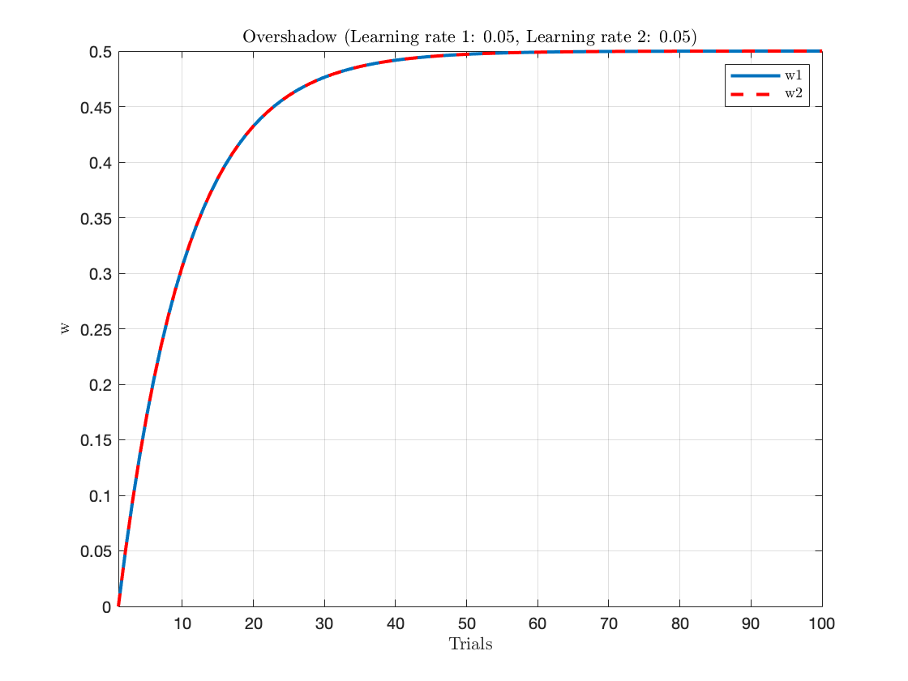

**Question:** Which one the predictions of RW rule match the above table?

**Answer:** The Wagner method is able to predict the results.

1. **For overshadow condition, how can one have a different amount of learned value for each stimulus?**

We can do this by assigning two different learning rate values to each stimulus. This can see as unequal associability.

1. **Simulate the results shown in figures 1-2 in the Dayan and Yu paper.**

First of all, I created the Kalman Filter in Matlab; it has some input such as Measurement noise, Process noise, and Present stimulus, and Σ and this is the result:

Figure 1B: we have this equation : 𝑤(𝑖 + 1) = 𝑤(𝑖) + 𝑣(𝑖)

Where v(i) comes from a normal distribution of mean zero and variance τ

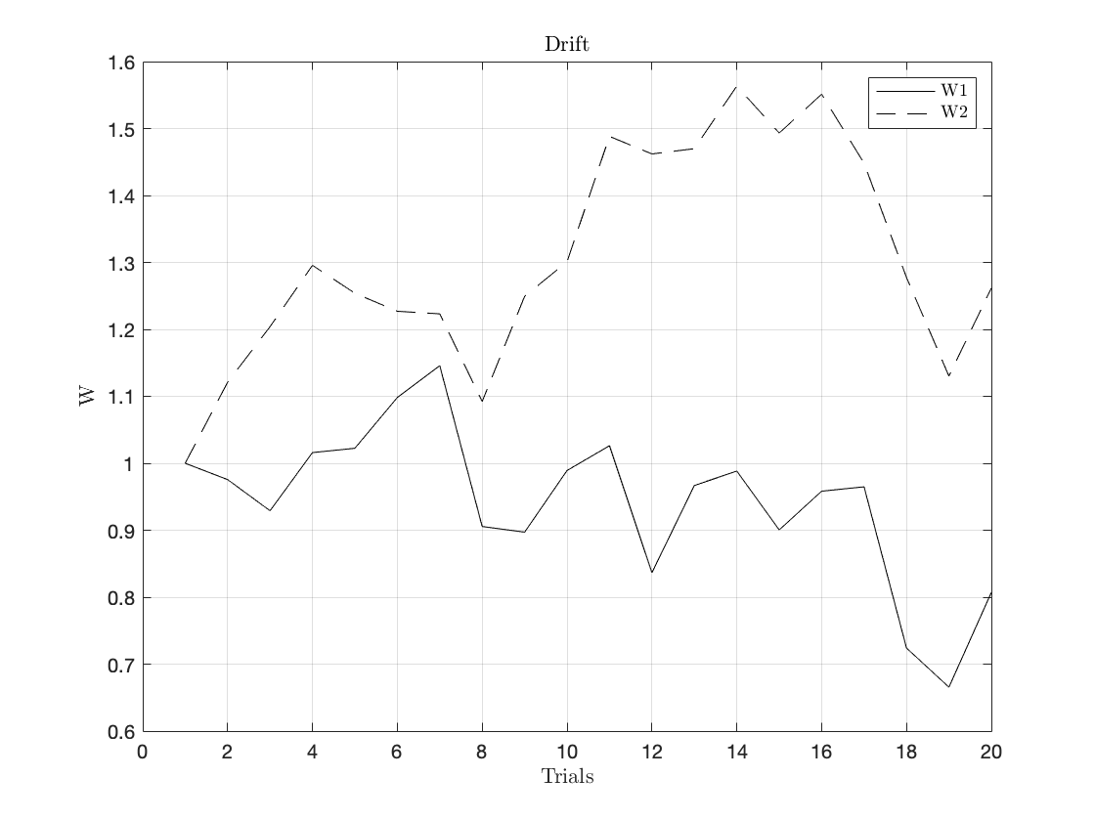

**Blocking:**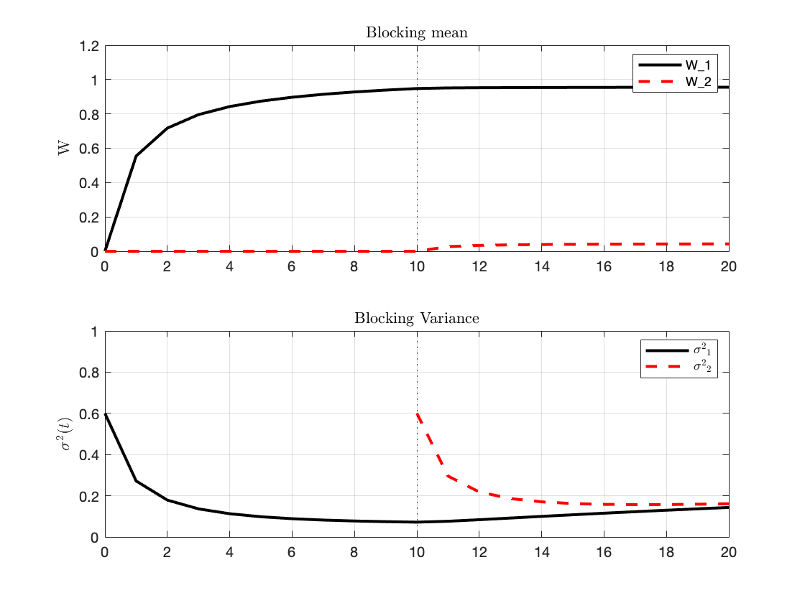

**Unblocking:**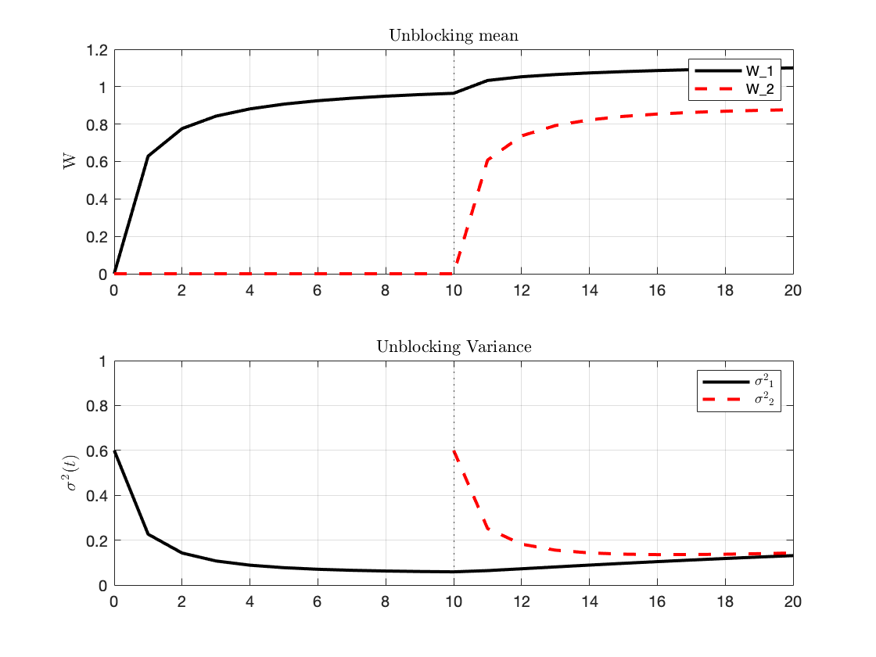

**Backward Blacking:**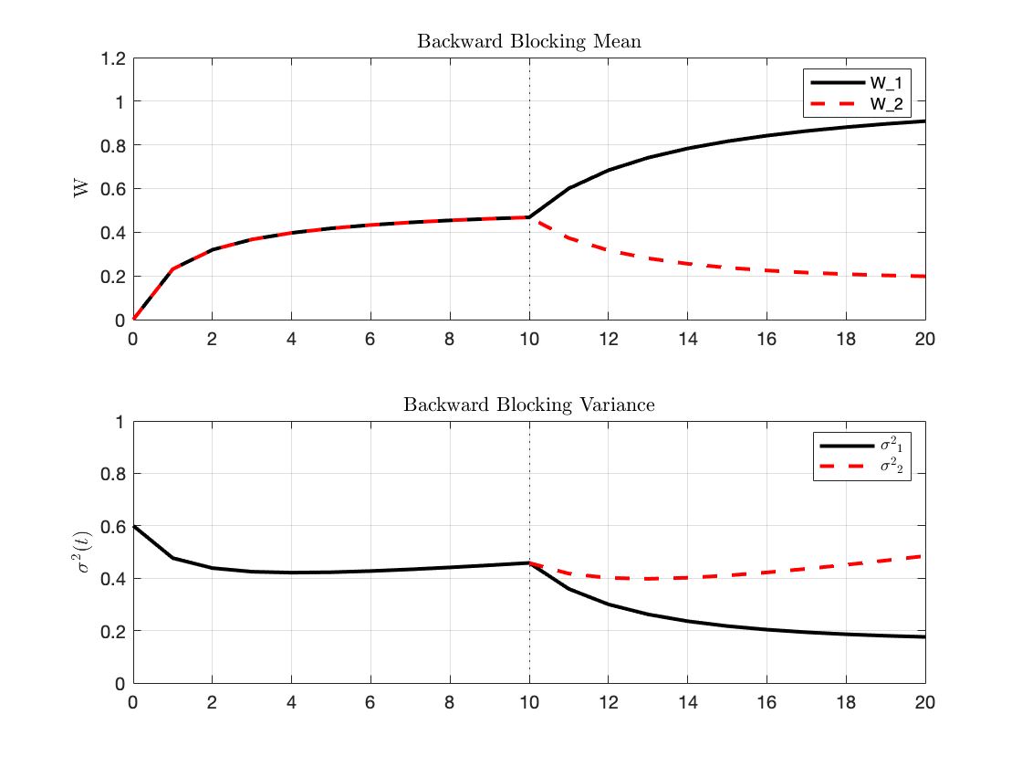

**Joint Distribution:**

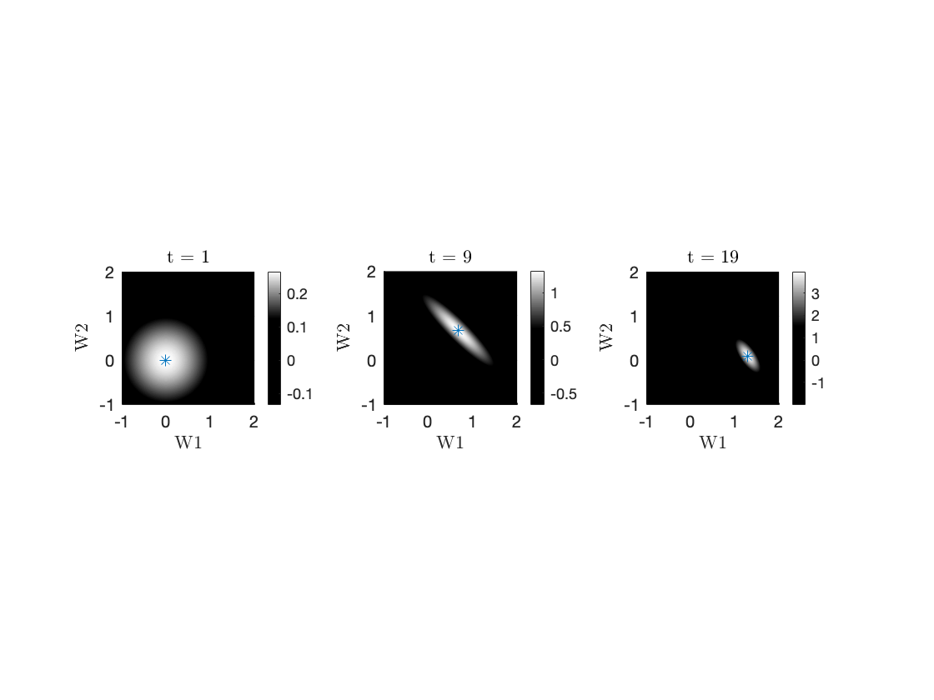

1. **How does result change by changing process noise vs measurement noise?**

**Blocking: (M_noise increase)**

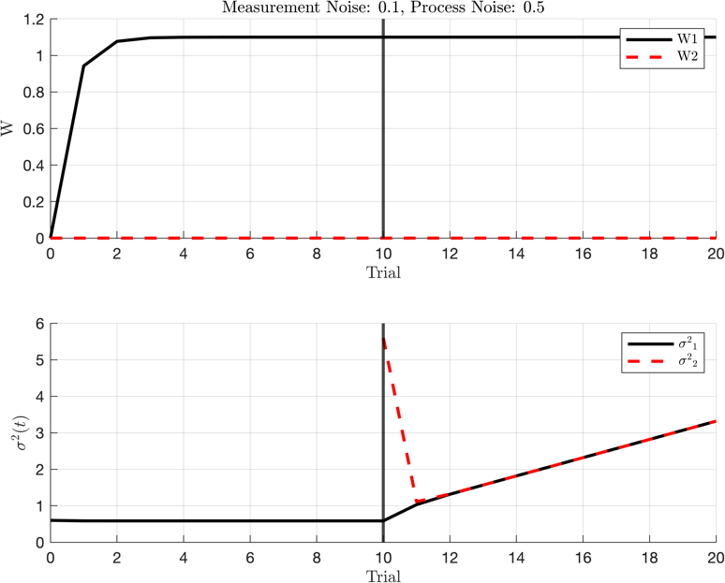 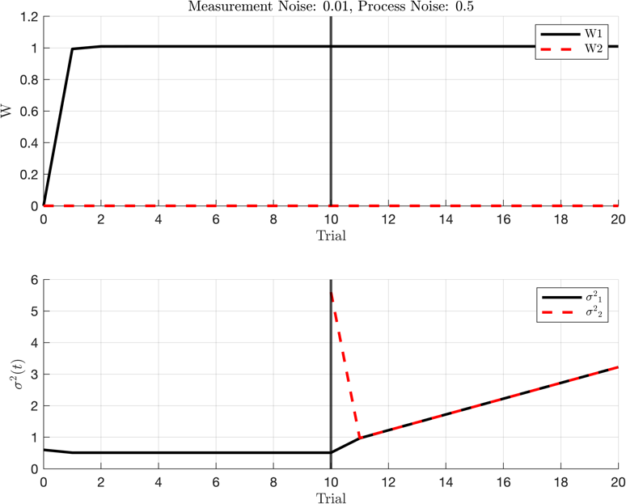

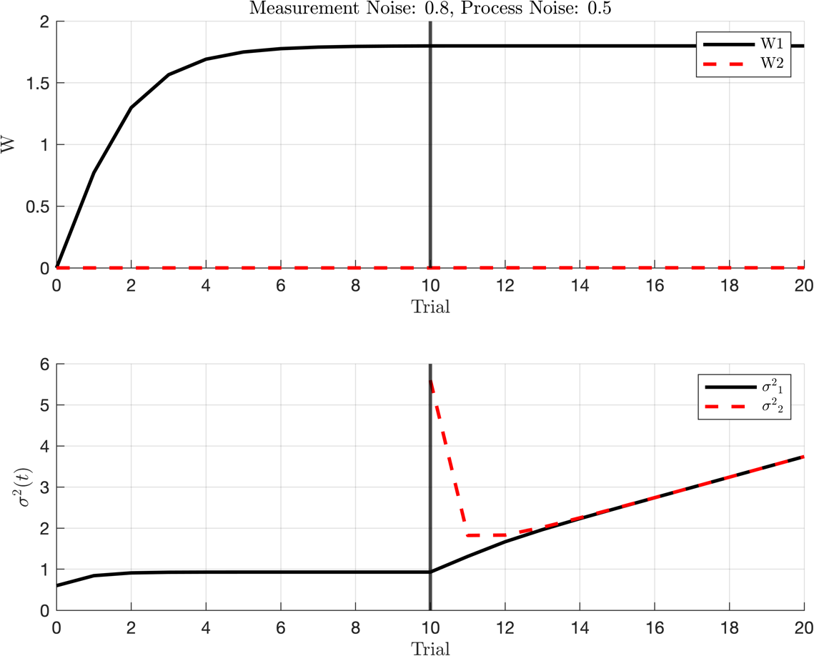

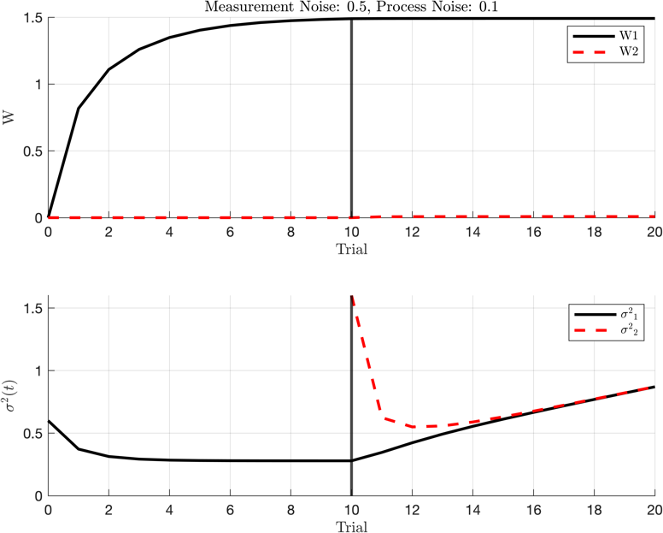**Blocking: (P_noise increase)**

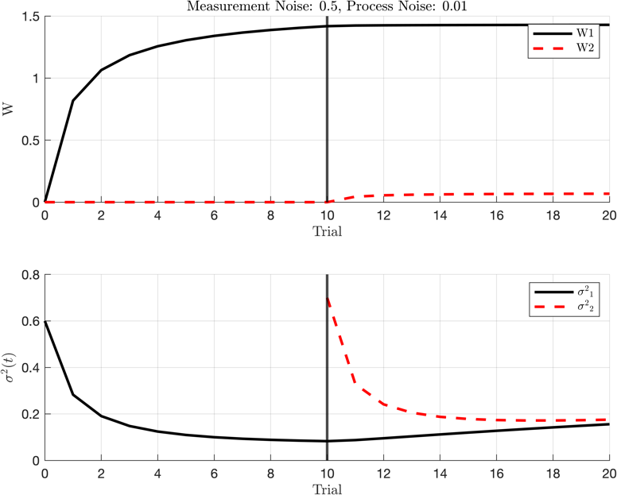

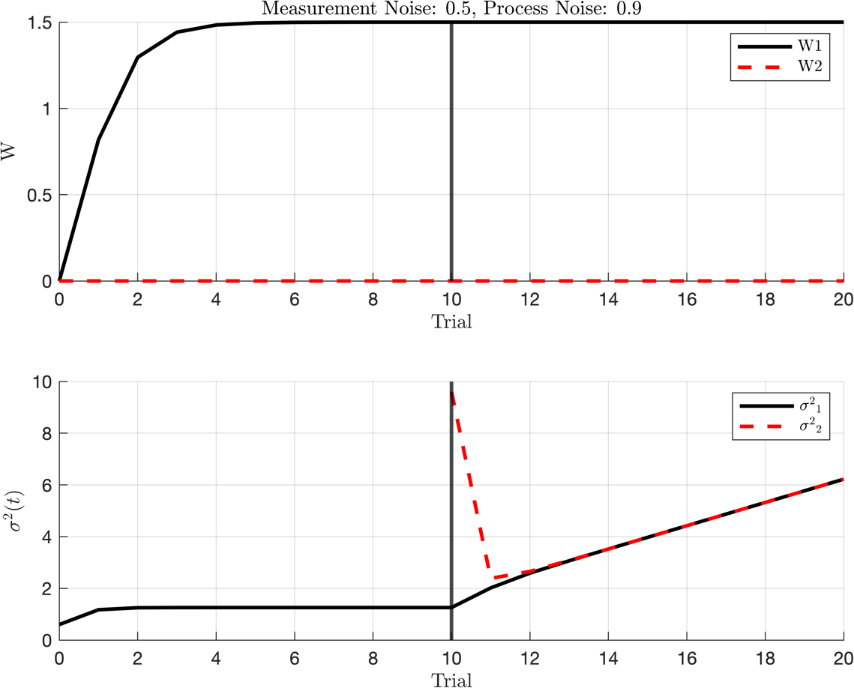

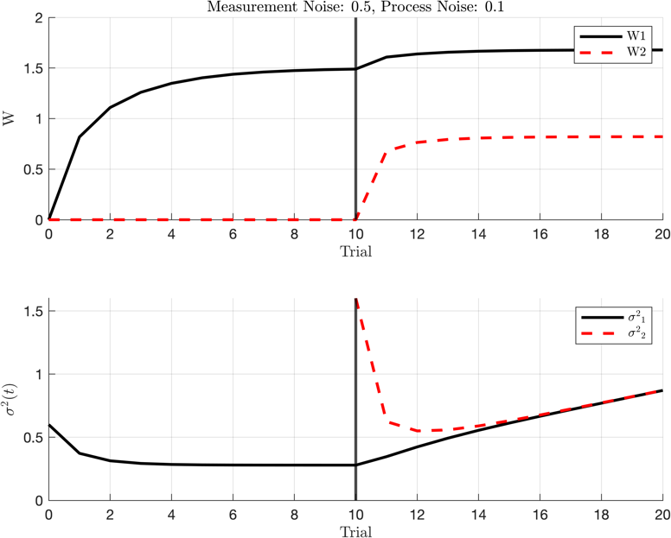**Unblocking: (P_noise increase)**

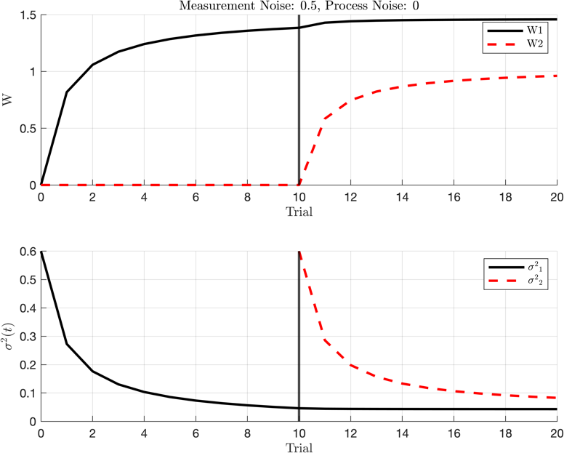

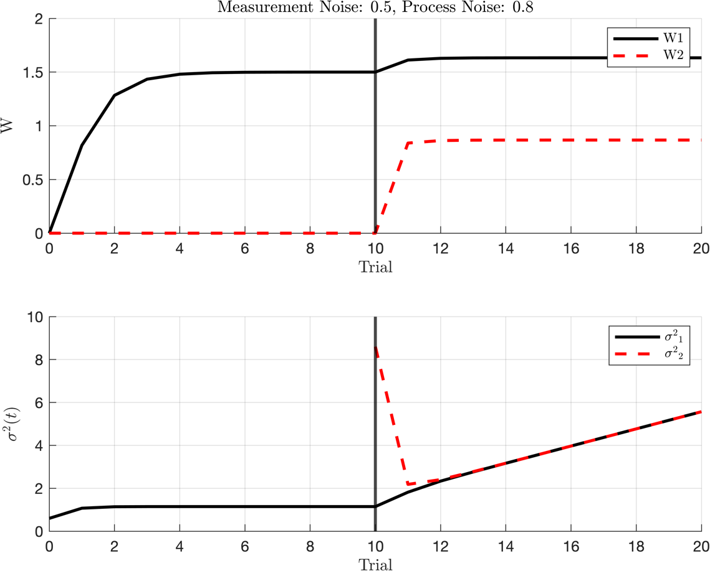

**Unblocking: (M_noise increase)**

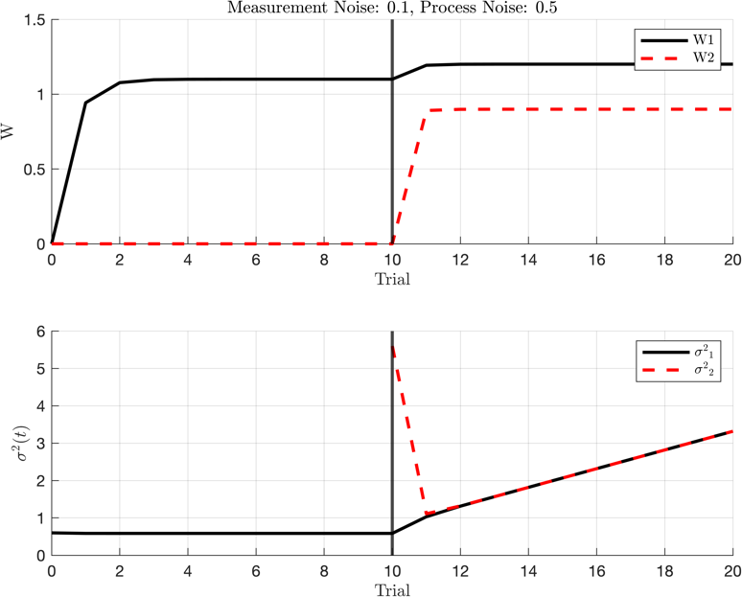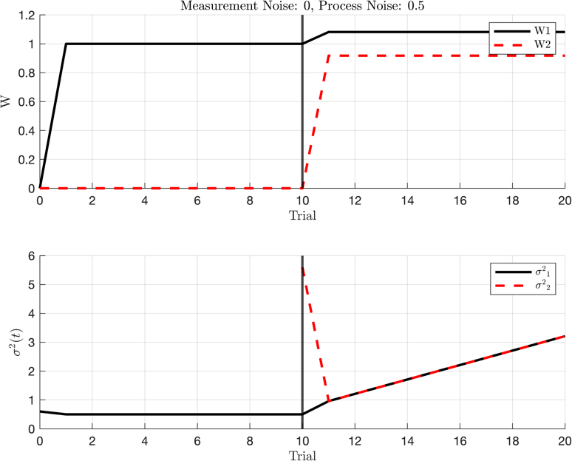

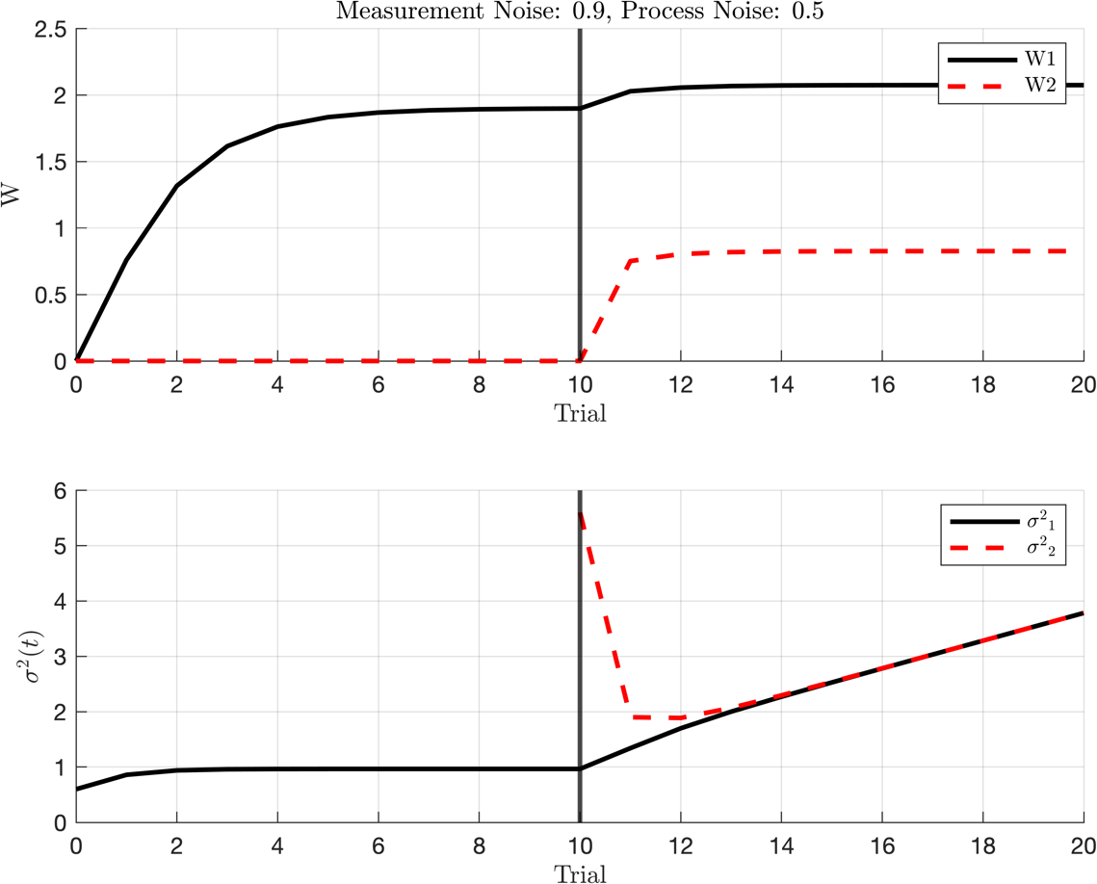

**Joint Distribution of W1 and W2:** 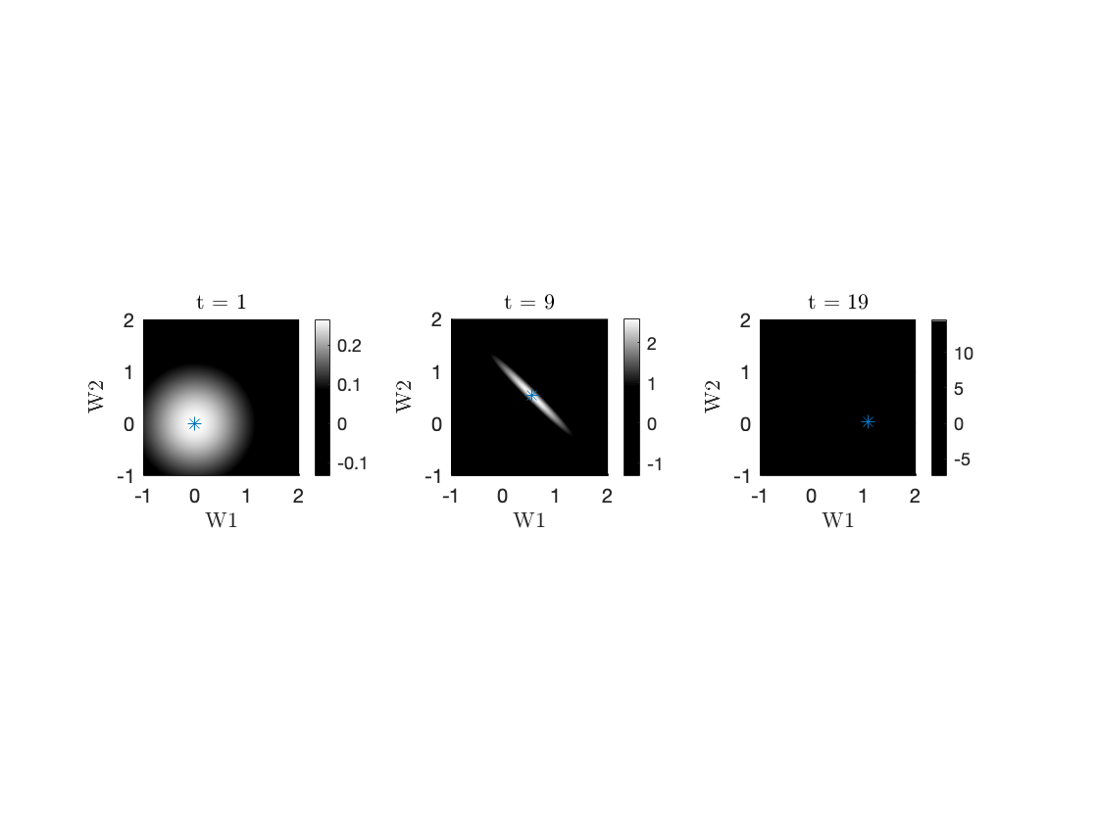



1. **What factors determine the value of Kalman gain at steady state?**

calculate :

Combining:

1. **Does the change in uncertainty depend on the errors made in each trial or changes in the learning context?**

In the Kalman Filter, change in uncertainty doesn’t depend on the errors refer its formula but in real world we already know that the change in uncertainty fully dependable on the errors which made in trial.

1. **Using this paradigm if we learn S1-> ‘r’. first and then S1->’-r’**

This is result of this simulation: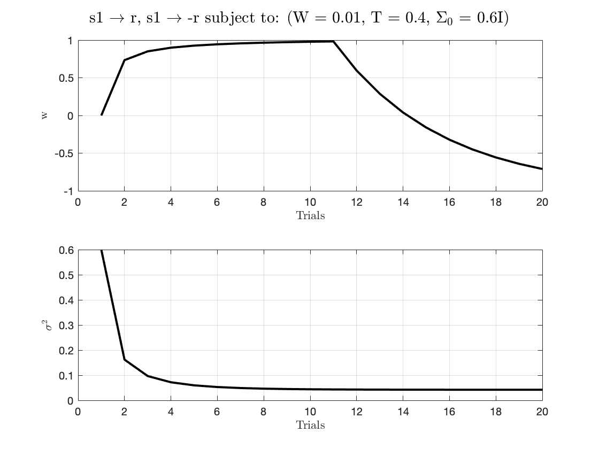

Explain the result: learning in the second partis much slower than the first. This means that whatever is being learned or processed is happening more quickly in the beginning, and then it slows down.

The term "learning rate" refers to how fast learning or improvement is happening, learning rate gets slower as more time passes.

In simpler terms, think of it like running a race. At the start, you have a lot of energy (high learning rate) and you run fast (first stage of learning). But as you continue running, you get tired (sigma decreases), you slow down (learning rate decreases), and this happens regardless of the environmentor the trophy you'll get at the end (reward).

1. **Simulate the results shown in Figure 3 of the paper.**

